Domain Trusts

Two-way trust relationships:  
1. CORP.cvscaremark.com and MinClinic.local  
2. CORP.cvscaremark.com and CaremarkRX.net

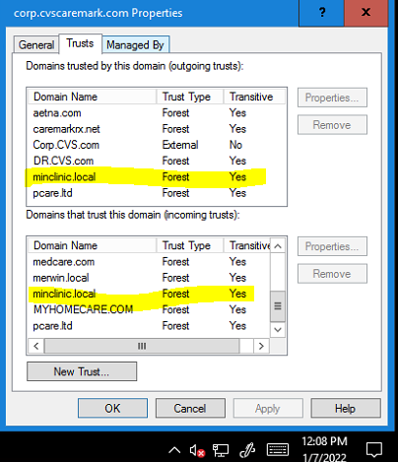

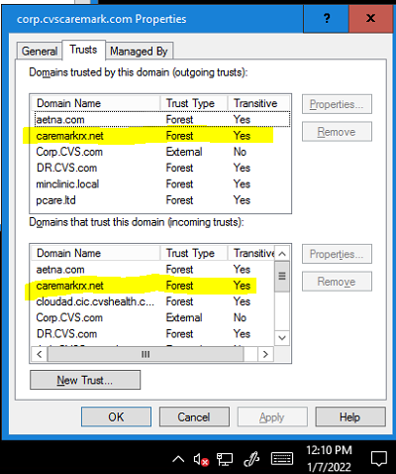

3. MinClinic.local and CVS.com

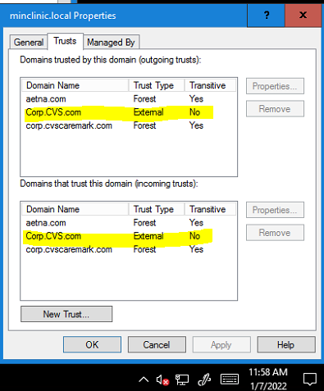

4. AETH.aetna.com and MinClinic.local

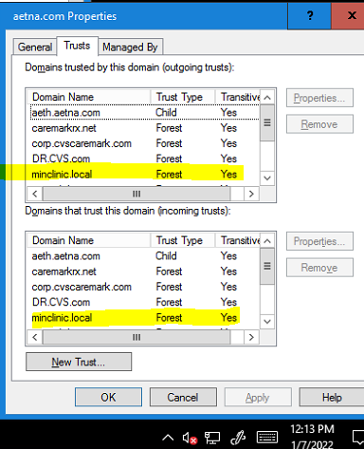

Aeth.aetna.com is a subdomain or aetna.com which is the AD forest. The forest trusts include all subdomains.

